Elisha & the Widow’s Oil
2 Kings 4
“Loved more than Sparrows” bird glider craft

No problem is too great or too small for our loving God! Jesus taught His disciples how much God cares for each of us. He said: Aren’t five sparrows sold for two pennies? But God does not forget even one of them. In fact, He even counts every hair on your head! So don’t be afraid. You are worth more than many sparrows. Luke 12:6-7 If God takes care of the smallest bird in the sky, He will certainly take care of those who trust in Him.

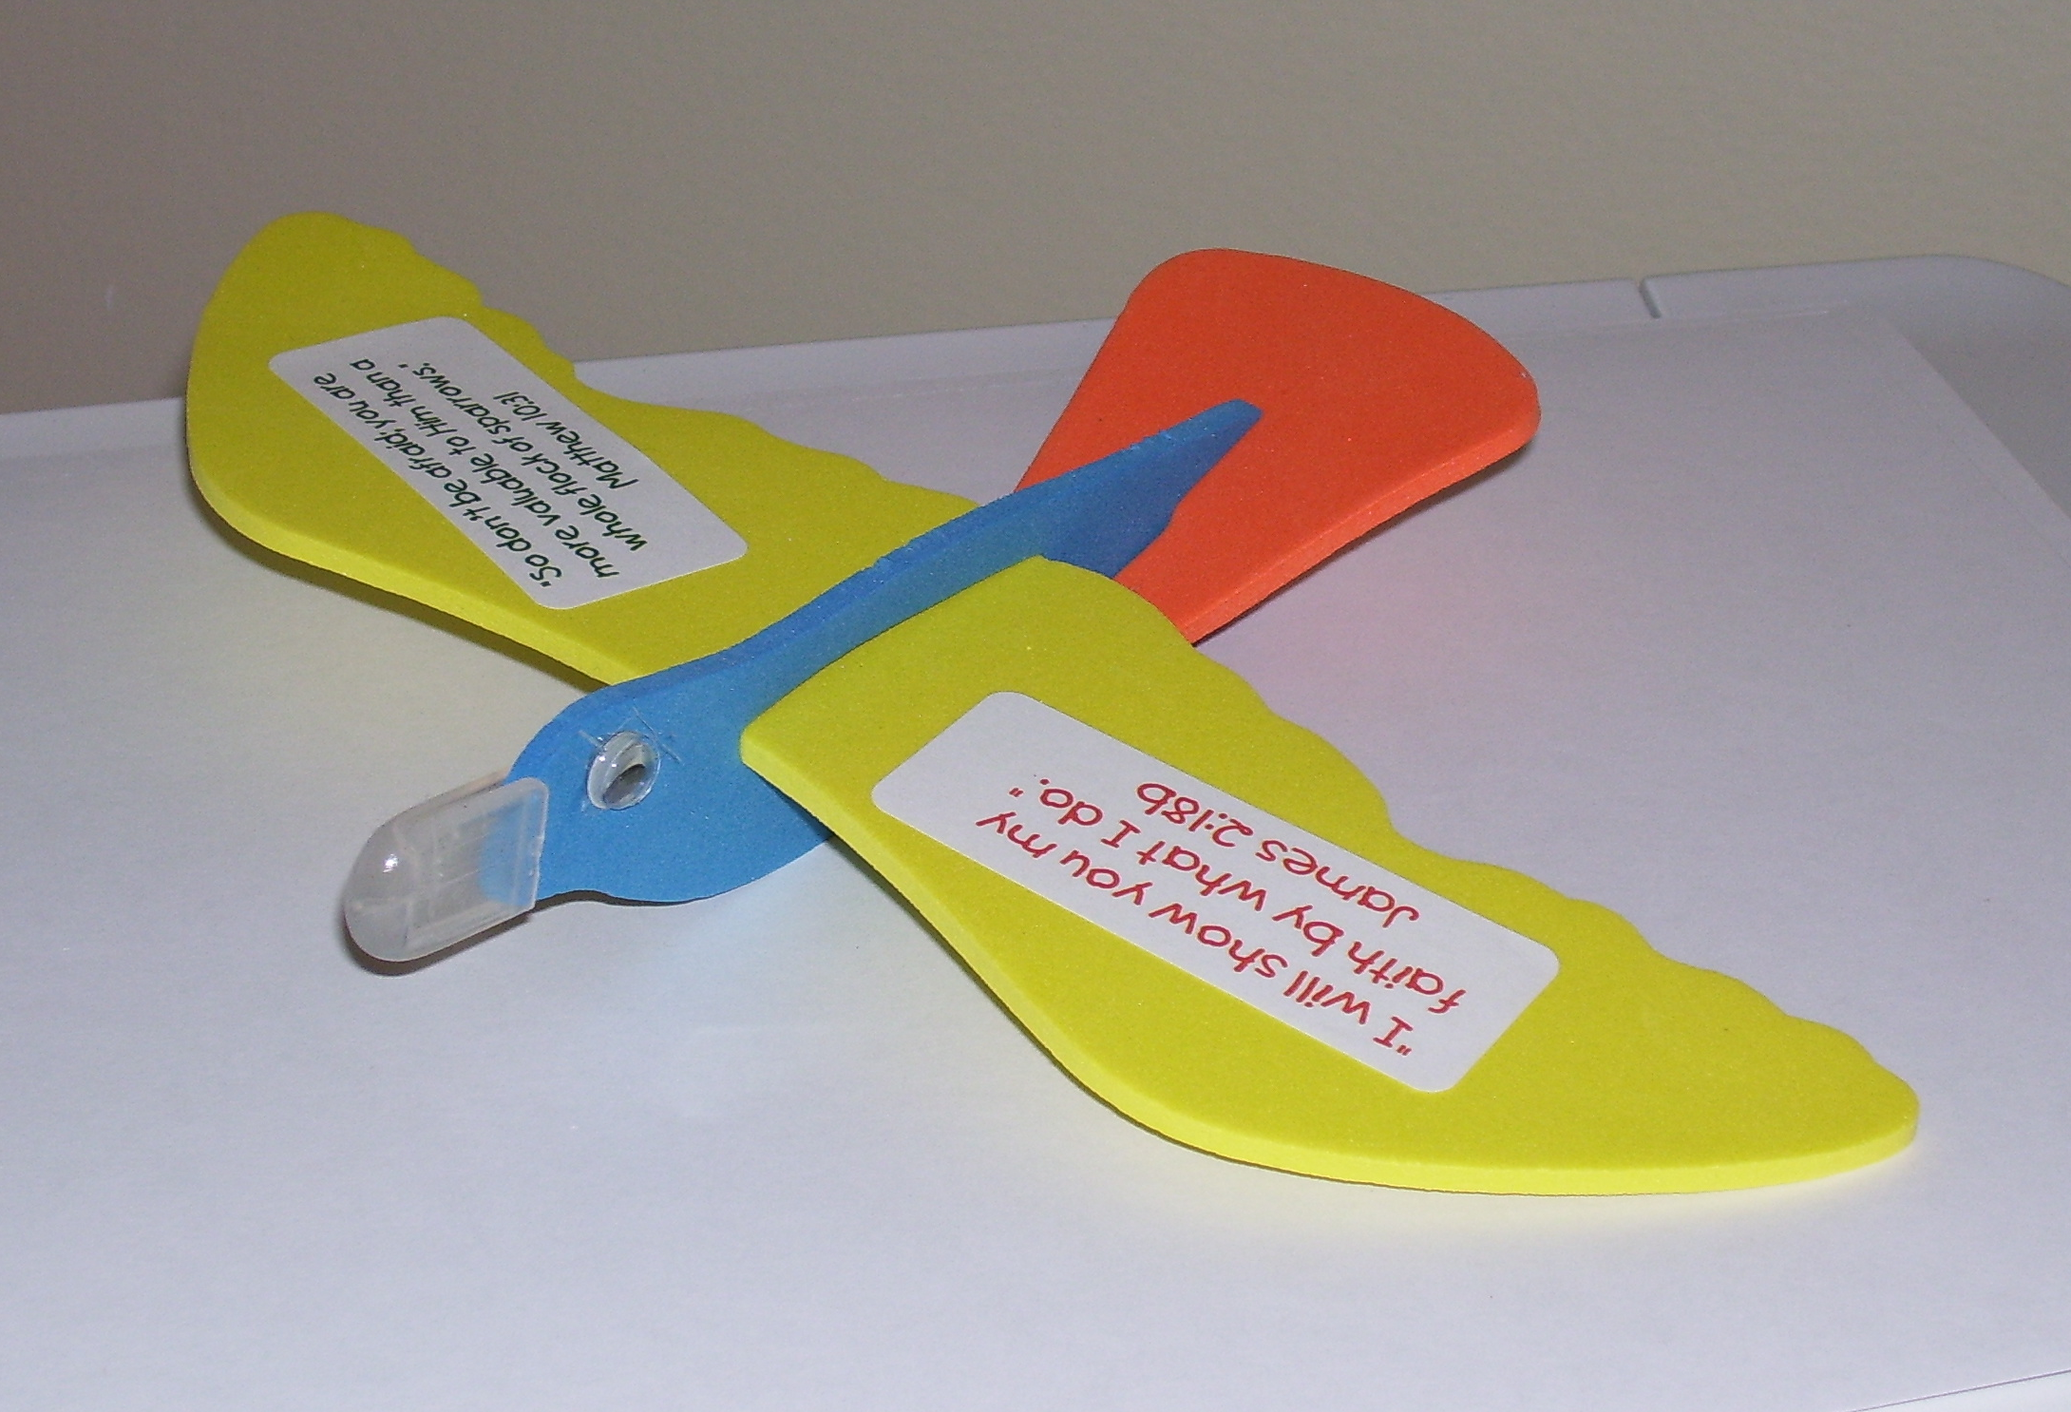

Directions:
- Put together wings and tail of bird glider craft, www.orientaltrading.com, 48/3075
- Add nose piece
- Glue eyes to head with tacky glue
- Add Bible Verse sticker to wings
- Decorate with foam stickers

